**REPORT**

Object Detection in a Cluttered Scene Using Point Feature Matching.

**Task:**

To detect a particular object in a cluttered scene, given a reference image of the object. The task presents an algorithm for detecting a specific object based on finding point correspon­dences between the reference and the target image. It can detect objects despite a scale change or in-plane rotation. It is also robust to small amounts of out-of-plane rotation and occlusion.

Note: Algorithm is designed for detecting a specific object present in an image.

**Input Images:**

**E.g:**

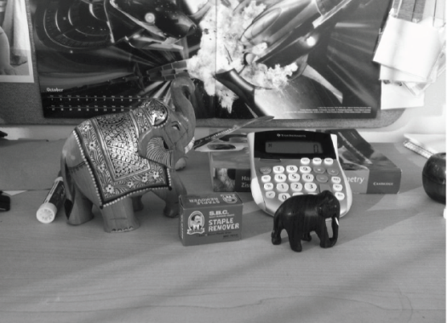 

**Features Extraction:**

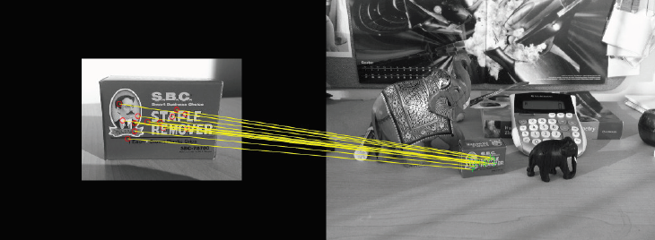

**Expected Output:**

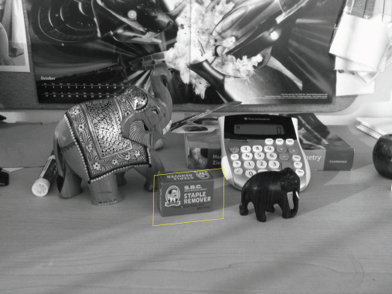

**Steps need to be followed:**

Step 1: Reading the Images.

Step 2: Detecting Feature Points.

Step 3: Extracting Feature Descriptors.

Step 4: Finding Putative Point Matches.

Step 5: Locating the Object in the Scene Using Putative Matches.

Step 6: Detecting different Object.